CTM-I Use Case

Broker Contact List

Version 0.1

Use Case Name | Broker Contact List
Actor | CBOE Firm, Market Ops, Operations, App Support
Q | User has Browser and is aware of the http path to the application.  User has successfully logged into the CTM-I application.  User has the right role to see the menu options.
Post Conditions | None
Screenshot | 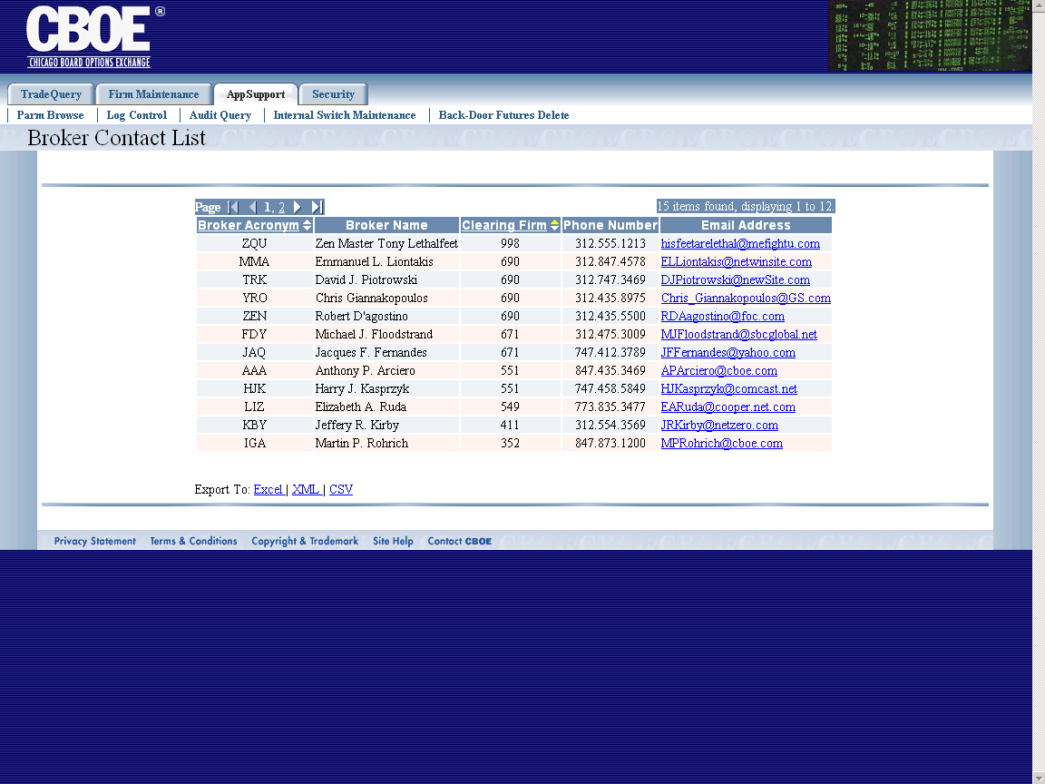
Flow of Events | - User selects “Broker Contact List” from the menu.  - Broker Contact list screen appears  - A list of all authorized brokers will be requested from Global or CTM-R.
Alternative Path | None

